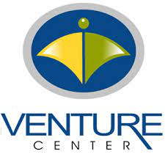
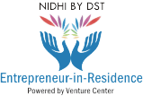
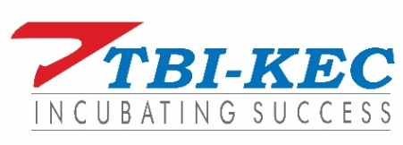
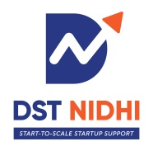
ELIGIBILITY and T&C FOR NIDHI-EIR SUPPORT
- The EIR applicant should be citizen of India. An Indian citizen is defined as one who is in possession of a government approved proof of nationality such as a valid passport, voter’s id etc.
- The applicant will submit application in the format prescribed by DST along with the undertakings mentioned in the Part E of the Application.
- The EIR applicant should have completed
- Minimum 4 years of formal full time undergraduate/ post graduate education towards one or more degree programme. Basic degree or diploma should be in science or engineering.
OR
  - 3 years degree or diploma program and have 2 year full time work experience post degree or diploma. Basic degree or diploma should be in science or engineering.
- The EIR is expected to be committed to exploring a business idea. Typical NIDHI-EIR needing the support is a first generation innovative entrepreneur, who has no parallel source of income. NIDHI-EIR support recipient should not treat this support as a stop gap arrangement to support them in their academic pursuits or transition between jobs.
- NIDHI-EIR seeking the support should demonstrate his ability to build a scalable technology business start-up. The background of the NIDHI-EIR needs to be provided in a prescribed format.
- The NIDHI-EIR support recipient should propose one technology business idea in a prescribed format.
- NIDHI-EIR support recipient are expected to pursue their entrepreneurial aspirations full time. NIDHI-EIR cannot be concurrent with any other remuneration or fellowship.
- NIDHI-EIR support recipient cannot be the promoter or significant (>10%) share holder / beneficiary of another company at the time of applying for and receiving the grant approval
- The NIDHI-EIR should be registered for the pre-incubation or incubation program at the TBI for the entire duration of NIDHI-EIR support.

ELIGIBILITY and T&C FOR NIDHI-EIR SUPPORT
- Preference shall be given for a) technology business ideas with larger technology uncertainties and/ or long gestation periods, b) technology business ideas leveraging technology or IP from publicly funded research or academic organizations, c) technology business ideas with considerable potential for social impact.
- Entrepreneurs pursuing business ideas with no or marginal technology innovation or those with very short journey (i.e less than 6 months) to commercialization are discouraged to apply.
- NIDHI-EIR seeking support should have a formal business plan for the idea they intend to pursue and a business presentation including the investment proposal.
- Other Terms and Conditions:
- Applicant will pursue NIDHI-EIR full-time with no other concurrent commitments, and will be fully committed to exploring a business idea. NIDHI EIR support recipient should not treat this support as a stop gap arrangement to support them in their academic pursuits or transition between jobs.
- Applicant confirms that he/she will not be in receipt of any other remuneration or fellowship during the duration of the NIDHI-EIR.
- Applicant and their team members should not have availed of any NIDHI-EIR grant in the past or similar support previously for the same innovative concept as proposed in this form. NIDHI-EIR can be used only once.
- Applicant if selected for NIDHI-EIR, then they (applicant and their team members) can avail support for their project from only one NIDHI-EIR TBI. If the applicant is found seeking NIDHI-EIR support for the same idea from two different TBIs, then the TBI reserves right to discontinue the EIR support and appropriate action will be taken on the applicant.
- Applicant & their Team members cannot avail the funding support simultaneously from both the schemes i.e NIDHI-PRAYAS and NIDHI - EIR, from the same or different TBIs.

